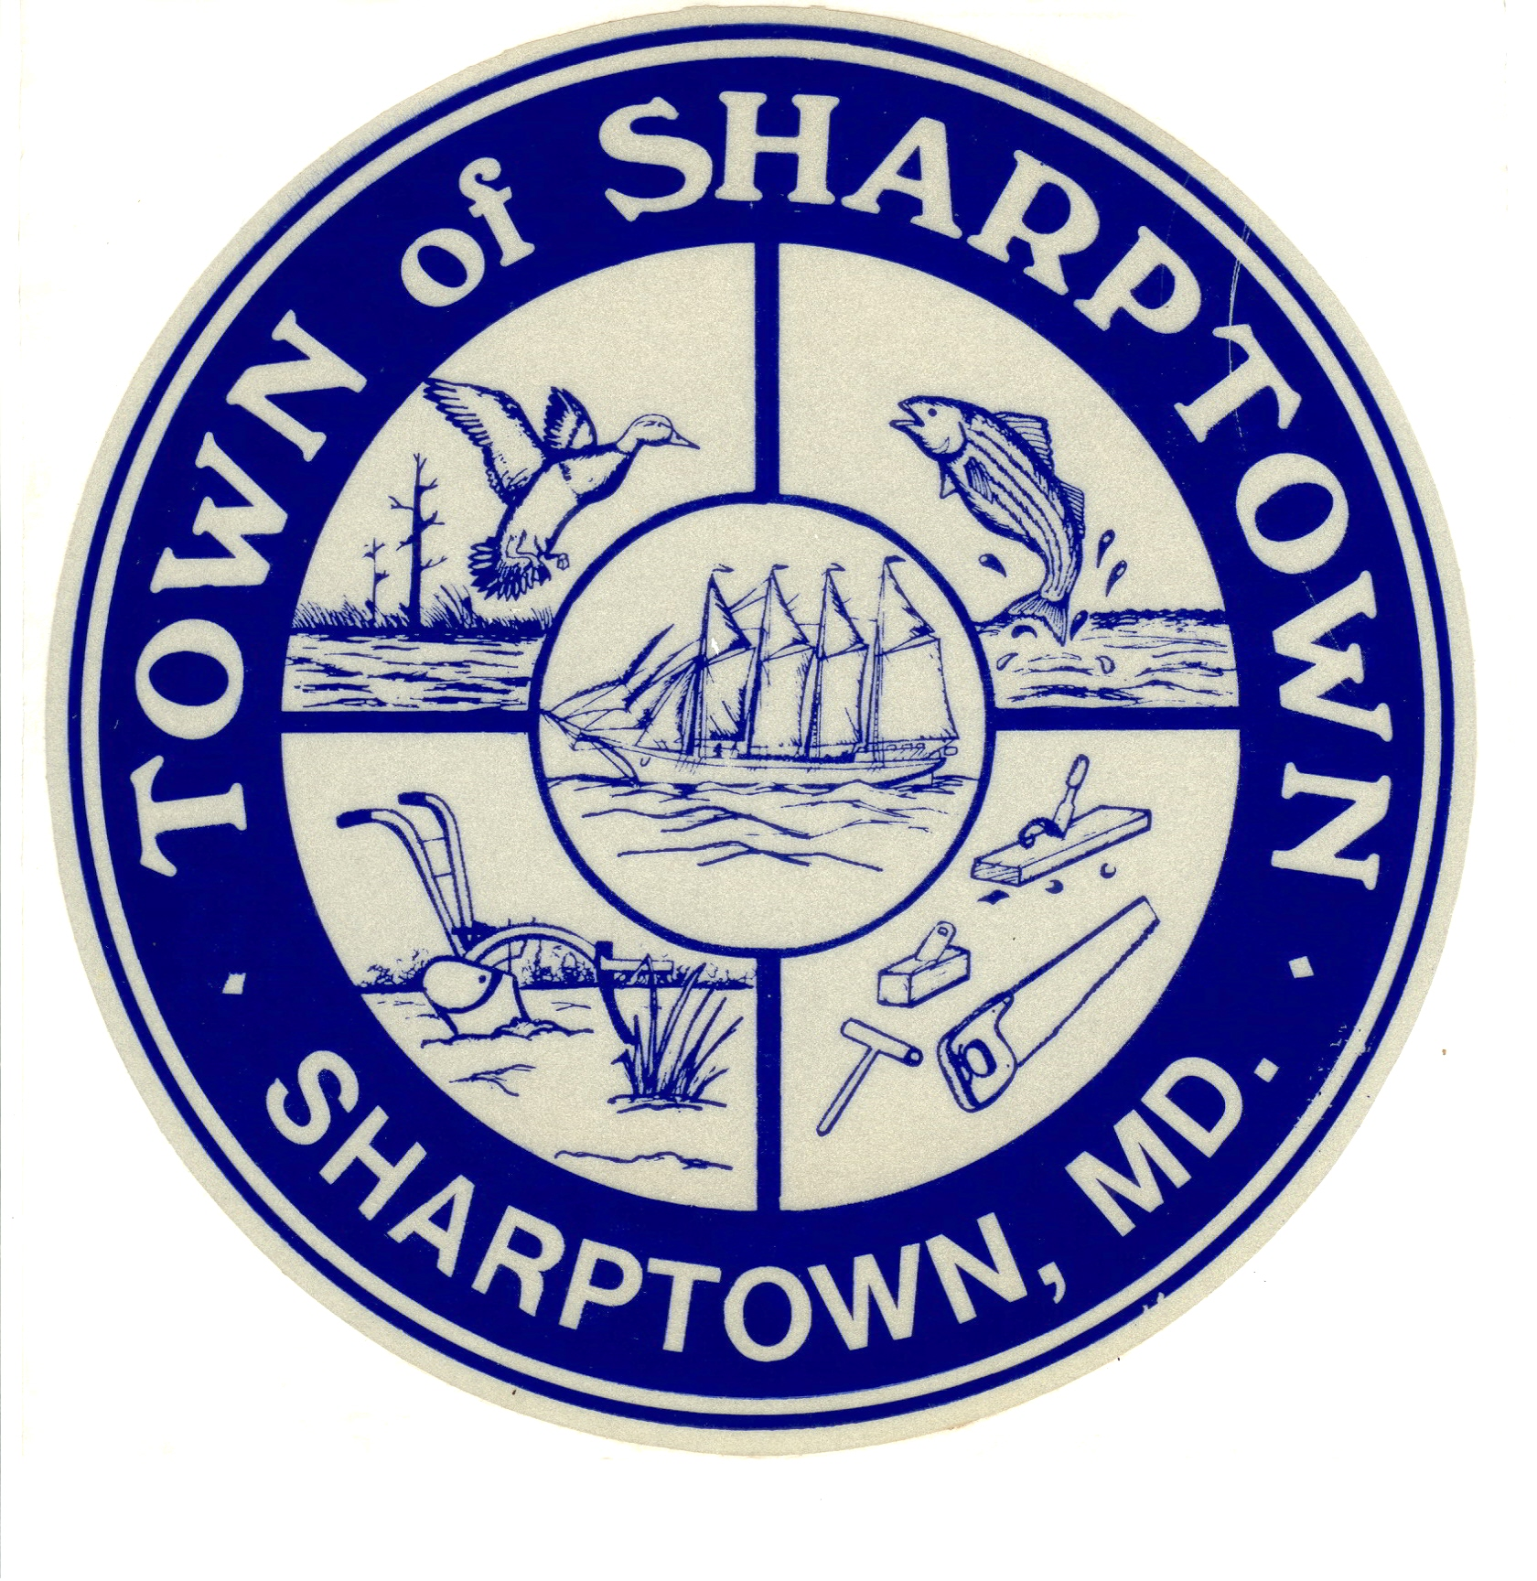

Regular Meeting Agenda
August 21, 2017

Meeting cancelled due to a lack of quorum

